Walkthrough – Hackable II

Contents

Host Discovery 2

Nmap 2

Viewing Website 2

Nikto 3

Dirb 3

Exploitation 3

Escalation 3

Upgrade Shell 3

Finding binaries 4

Finding the file 4

Crackstation 4

Flag 1 5

Python Exploitation 5

# Host Discovery

**Kali**: 192.168.56.101

**Victim**: 192.168.56.147.

# Nmap



# Viewing Website



This is the hint.

# Nikto



# Dirb

# Exploitation

Since FTP allows anonymous login I can log into it. I notice that the /files/ directory contains CALL.html which also shows up in the FTP server. This means I can upload a file called shell.php to setup a reverse shell connection.

Next, set up a reverse shell on the kali machine to listen to the same port.

Now I am in.

# Escalation

## Upgrade Shell

In the home directory I can see a txt file called important.txt.

## A screenshot of a computer Description automatically generatedFinding binaries



This was nothing of use.

## Finding the file



This is in the root directory.

This gives me the password for the shrek account.

hash: cf4c2232354952690368f1b3dfdfb24d

## Crackstation

Credentials – shrek:onion.



Now I am inside the other user.

Given my current sudo permissions I can create a script that can spawn me a privileged shell.

# Flag 1

# Python Exploitation

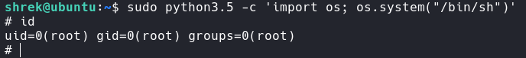I thought I was being smart however I ended up writing a program that didn’t actually read the file. However the program read all of the files in the root directory and found the flag name. However It failed to read it. It did read the bash_history file which showed a python one liner to escalation privileges. sudo python3.5 -c 'import os; os.system("/bin/sh")'.

